**Creating environments**

Postman displays the active environment in the environment selector, located in the top right of the workbench.

You can access all environments from **Environments** in the sidebar. Select the set active icon Set active icon next to an environment to make it the active environment.

Select an environment's name to open the environment editor.

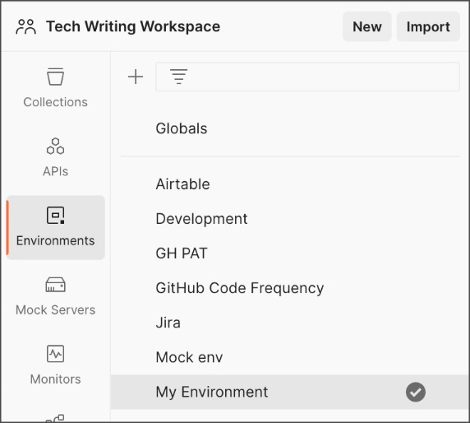

The environment quick look icon Environment quick look icon is next to the environment selector. The environment quick look lists variables for the active environment, and any global variables you have declared or that are shared in your workspace.

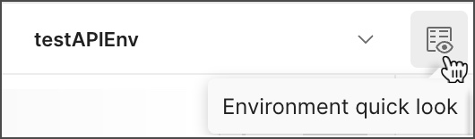

To create a new environment, do the following:

1. Select **Environments** on the left and select **+**.

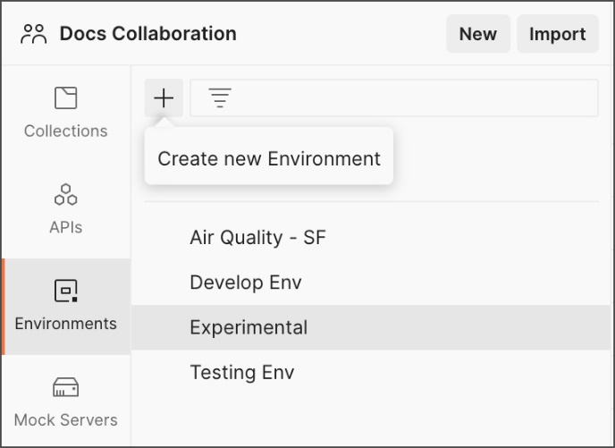

1. Enter a name for your environment, and initialize it with any variables you need. You can also specify variables for the environment later.
2. Select **Save** to save any environment variables you have added.

You can turn on autosave to automatically save your changes to collections, requests, and environments. Learn more about [autosave](https://learning.postman.com/docs/getting-started/installation/settings/#application).

**Adding environment variables**

You can add variables to an active (currently selected) environment by opening the environment from the sidebar and editing it in the tab that opens.

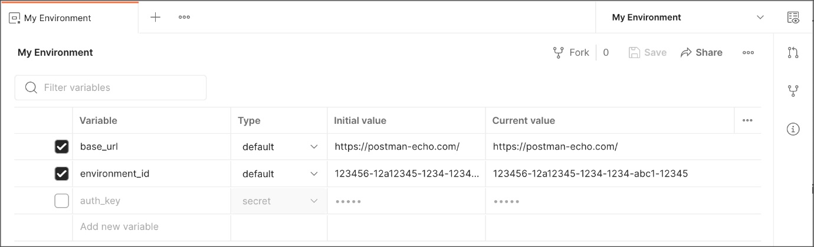

Edit the variable names and values inline, or use the close icon Close icon to delete a variable. Enter the name and values for a new variable on a new line. **Save** when your changes are complete.

Alternatively, select the environment quick look icon Environment quick look icon and edit inline.

If you are working with environment variables as part of a team, you will only be able to change initial values if you have [edit access to the environment](https://learning.postman.com/docs/sending-requests/managing-environments/#managing-environment-roles). You can access all variables in environments shared with you, but may have read-only access to initial values if you have a Viewer role.

Enter a name for your variable, and specify its **Initial** and **Current** values. By default the current value will copy the initial value.

* The **Initial value** is synced to your account using the Postman servers. It's shared with any collaborators who have access to the environment.
* The **Current value** is used in your local instance of Postman, and is never synced to your account or shared with your team *unless you choose to persist it*.

To update the synced variable with your local value, set the initial value to the current value by selecting the more actions icon More actions icon and choosing **Persist**. To reset your local (current) value with the synced value shared with your workspace / collaborators, select **Reset**. You can persist or reset all values in the environment using **Persist All** and **Reset All**.

You can also define environment variables by **Type**. Variables are automatically assigned the default type when created, which is shown as plain text and has no extra properties. You can change sensitive variables to [secret type](https://learning.postman.com/docs/sending-requests/variables/#variable-types), which masks the initial and current values for all workspace members. Secret type can be used to prevent unintentional disclosure of sensitive data, including API secrets, passwords, tokens, and keys.

**Accessing environments**

You can access your environment variables from Postman and from your request elements, including the URL, parameters, body data, and test scripts.

For the list of all your environments, select **Environments** in the sidebar.

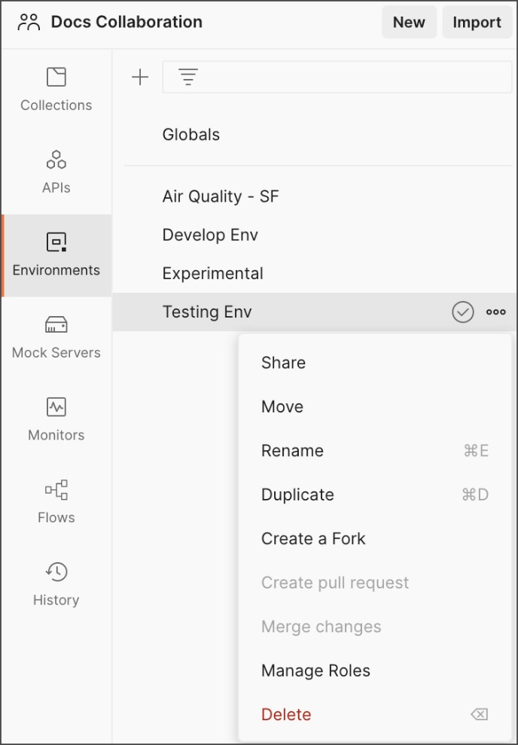

Here you can add, share, duplicate, download, manage access, delete, and remove a shared environment from a workspace. You can also access your global variables by selecting **Globals**.

To view the variables in an environment, select its name. You can edit, add, and remove variables from the environment here. You can also use the **Filter variables** control to search for variables in the environment.



**Selecting an active environment**

To use the variables in an environment, select it from the environment selector at the top right of the workbench.

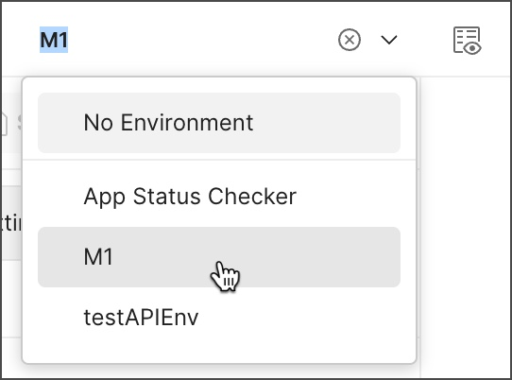

To check a variable value at a glance, use the environment quick look icon Environment quick look icon .

When you choose an environment using the environment selector, Postman treats it as the active environment and runs all requests with values from that environment (if your requests reference environment variables).

To use an environment variable value in a request, reference it by name, surrounded with [double curly braces](https://learning.postman.com/docs/sending-requests/variables/):

{{base_url}}

You can use the same variable notation in request URLs, parameters, headers, and body data.

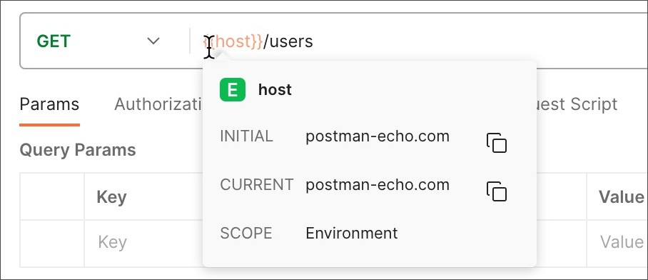

Hover over a variable reference to get its current value.

If more than one variable with the same name is available to a request, Postman will use the value from the variable with narrowest [scope](https://learning.postman.com/docs/sending-requests/variables/#variable-scopes). This means that if you have an environment variable with the same name as a collection or global variable, Postman will use the environment variable, but local and data variable values will supersede environment values. The value of any overridden variables will display with a strikethrough.

You can access current environment variable values in your **Pre-request** and **Tests** code.

pm.environment.get("variable_key");

You can publish environments with your [API documentation](https://learning.postman.com/docs/publishing-your-api/publishing-your-docs/) and the [Run in Postman button](https://learning.postman.com/docs/publishing-your-api/run-in-postman/creating-run-button/).

**Editing environment variables**

You can edit variables either by opening an environment from **Environments** on the left, or by selecting the environment quick look icon Environment quick look icon next to the [environment selector in the workbench](https://learning.postman.com/docs/getting-started/basics/navigating-postman/#environment-selector-and-environment-quick-look) and selecting **Edit**. You can sort the list of variables by selecting any column heading to toggle between alphabetical ascending or descending order and custom order. To sort the list by a custom order, clear the active sort then drag rows to reorder using the handle on the left-hand side.

You will only be able to edit environments where you have [Editor access](https://learning.postman.com/docs/sending-requests/managing-environments/#requesting-environment-access).



Edit the environment name, or the names, [types](https://learning.postman.com/docs/sending-requests/variables/#variable-types), and values of your variables, bearing in mind that **Initial values** will be synced with your Postman account and shared with any collaborators who have access to the environment. Select **Save** when your edits are complete.

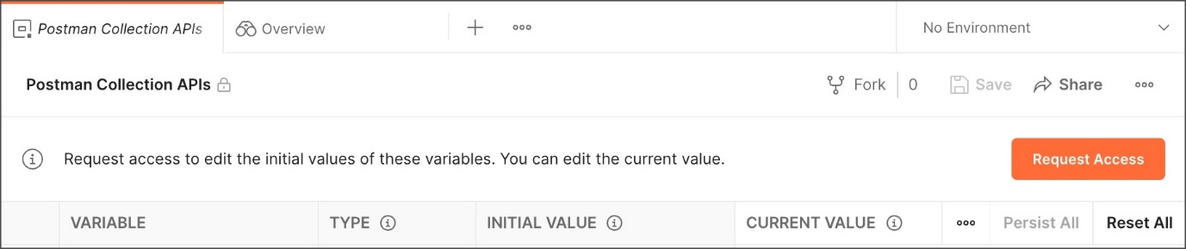

If you have Viewer access to an environment, a lock icon Lock icon next to the name indicates that it's read-only. You will only be able to edit the current value, which is visible only to you and not synced with your Postman account or workspace. To edit initial values you will need to **Request Access**.

You can edit current values for variables in an active (currently selected) environment directly using the environment quick look. Select the edit icon Edit icon to edit your chosen value.

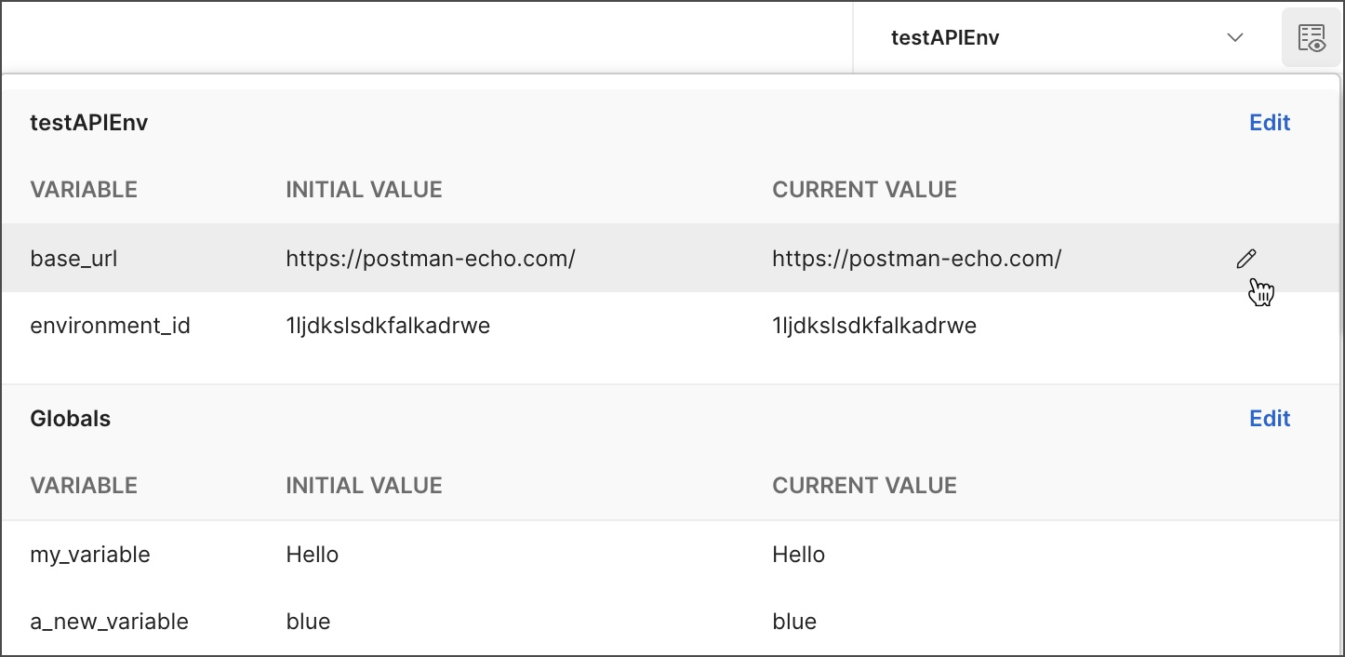

You can also update environment variable values from your test scripts.

**Setting environment variables from scripts**

Your **Pre-request** and **Tests** scripts can update environment variable values.

Use [pm.environment](https://learning.postman.com/docs/writing-scripts/script-references/postman-sandbox-api-reference/) to set an environment variable in the active (currently selected) environment:

pm.environment.set("variable_key", "variable_value");

You can only create new variables from a script in an environment that you have edit access to. If you update or unset a value in a script with Viewer access to the environment, that change will only be visible to you and not shared with your team.

If you use scripts to set environment variable values, these will be reflected for all requests referencing the variables. For example, you can use environments [in conjunction with the collection runner](https://learning.postman.com/docs/collections/running-collections/intro-to-collection-runs/) and [monitors](https://learning.postman.com/docs/monitoring-your-api/intro-monitors/) to share updated values throughout a run for a series of requests as well as after it completes.